**“DAMPY: Damath in Python | Documentation**

In Partial Fulfillment of the Requirements in the Major Subject

Modeling and Simulation

**Submitted by:**

Buenconsejo, Gian Paolo

Famoso, Nina Grace D.

Gavino, Bien D.

Malabanan, John Russelle B.

Masarque, Andy D.

Velano, John Kenneth M.

**Submitted to:**

Prof. Angelica P. Payne, LPT

Modeling and Simulation Adviser

December 2022

**TABLE OF CONTENTS**

Cover Page …………………………………………………………………………… 1

Definition of Terms ……………………………………………………………………

Project Description ……………………………………………………………………………

Project Scope ……………………………………………………………………………

Objectives ……………………………………………………………………………

Deliverables ……………………………………………………………………………

Success Factors ……………………………………………………………………………

Client/User Requirements ……………………………………………………………

Implementation ……………………………………………………………………………

Flowchart ……………………………………………………………………………… 3

Instructional Manual ……………………………………………………………… 4 – 8

Project Team ……………………………………………………………………………

Project Milestones ……………………………………………………………………………

References ……………………………………………………………………………

Acknowledgement ………………………………………………………………….… 9

**DEFINITION OF TERMS**

The following terms have been used in this documentation:

1. **Python**

A large heavy-bodied nonvenomous snake occurring throughout the Old-World tropics, killing prey by constriction and asphyxiation.

1. **Dama**

The Philippine version of Checkers, also known as draughts. It is a strategy board game for two players involving diagonal moves of uniform game pieces and mandatory captures by jumping over opponent pieces.

1. **Damath**

A two-player educational board game combining the board game “Dama” and mathematical operations.

1. **Dampy** (or DamPY, DamPy)

The video game version of Damath, which is the end result of this project.

1. **Application** (or App, Program)

A computer software package that performs a specific function directly for an end user. May also pertain to this project’s program, Dampy.

A popular general-purpose programming language. It is used in machine learning, web development, desktop applications, and many other fields.

**PROJECT DESCRIPTION**

Dampy is a game essentially based of off “Damath”—a strategy board game that is heavily inspired by the Philippine checkerboard game called “dama.” However, this Damath is conveniently combined with numbers and mathematics.

Damath was designed by Jesus Huenda, a secondary teacher from Sorsogon, Philippines. The board game uses 24 chips that may contain integers, or mathematical expressions like fractions, radicals, and polynomials. The expressions written on the chips may also be dependent on the grade level of the competing players. These chips are then placed on an 8x8 checkered board, consisting of 32 black and 32 white squares, with the arithmetic symbols +, -, x, and ÷ written on the white squares.

The information below are the rules, along with the instructions that will guide the user in understanding the concept of the game and how it should be played.

1. **Rules**

Damath is played by two players, and they will take turns in moving their chips.

1. A toss coin will decide which player will make the first move.

2. Players can only make moves in a diagonally forward direction, unless if it is taking a chip (capturing) or if a chip is already a king piece or in “dama,” which it can move in all four directions.

3. A chip can be promoted as a king chip when it stops on any of the squares in the opposing player’s first row. The following squares are (1,0), (3,0), (5,0), (7,0) for the bottom player, and (0,7), (2,7), (4,7), (6,7) for the top player.

4. The board has four operation symbols of +, -, x, and ÷ engraved on its white squares. When taking an opponent's chip/s, the “taker” chip jumps over the “taken” chip and uses any of the four operation symbols to calculate and earn their score, dependent on where the piece lands.

5. A king chip can slide diagonally, forward, or backward in any unoccupied square, allowing it to get past an opponent's chip that may be blocking its path,

6. The score obtained is doubled when a king chip captures an ordinary chip or when a chip captures an enemy king chip. The score is then quadrupled if a king chip captures an opposing player’s king chip.

7. The points are earned depending on the corresponding sum, difference, product or quotient, and the numbers on the chips.

8. The player with the highest accumulated total points becomes the winner of the game.

* 1. **Board**

The Damath board resembles a standard 8x8 checkerboard, but with arithmetic symbols (+, -, ×, ÷) written on them. These operations are used to calculate the points earned, depending on where chips land.

*Fig. 1: Damath game board in Dampy*

* 1. **Chips** (or Pieces)

The chips used in Damath look like the ones used in checkers but have numbers or mathematical expressions written on them.

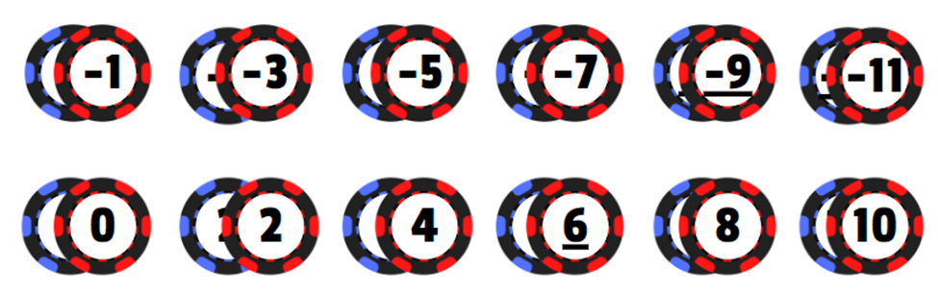  
*Fig. 2: Damath pieces used in Dampy*

* 1. **King Chips**

A chip can be a king or a “dama” chip when it stops in the following squares of the opposing player: (1,0), (3,0), (5,0), (7,0). The opposing player’s chip can also be dama when it lands in the following squares: (0,7), (2,7), (4,7), (6,7). King chips are able to move diagonally in all four directions, unless an opposing chip is blocking its path, which it can then capture, unless there is another chip behind it.

*Fig. 3: King pieces used in Dampy*

* 1. **Scoring**

Mathematical operations are used to calculate the score earned. When a “taker” chip jumps over the 'taken' chip and uses any of the four operation symbols to earn points, depending on where the piece lands.

In the figure below, upon the capture of the “4” chip of the “6” chip, it will land on a + symbol, thus performing an operation of 4 + 6 = 10. The end result will be added to the taker’s score.

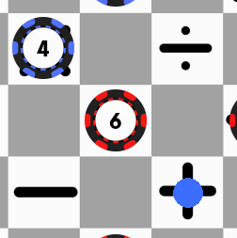  
*Fig. 4: Sample scoring in Dampy*

* 1. **Winning Condition**

If there is no more valid moves, the remaining chips will be added to their score of the player who still has valid moves. The game also ends if one player has no more pieces left to move. The winner of the game is the player with the highest accumulated total of positive points.

**PROJECT SCOPE**

**WORK TO BE ACCOMPLISHED**

To develop Dampy, a fully-fledged video game for desktop computers made for entertainment and numeracy exercises. It is inspired by the conventional “Damath” game, although integrated in modern and digital technology, making it convenient and easily accessible at any time of the day.

**PURPOSE**

The chief purpose for which this application is made is to provide entertainment for users by engaging them into a 2-player game of combined strategy and mathematical prowess. The application can also serve as a learning material for students who want to enhance their grasp of the four fundamental operations of integers.

**STAKEHOLDERS/USERS**

Although the game has a wide spectrum of potential users, it is primarily intended to those who fancy simple board games and mathematics, to those want to hone their mathematical skills, and to people who wants to play a quick yet competitive virtual board game with their friends.

**OBJECTIVES**

**SCHEDULE**

The project’s scheduling objectives consist of the following:

(1) to be able to fully develop a working and playable “Damath” video game—hereinafter referred to as “Dampy,” within our instructor’s given timeframe.

**TECHNICAL**

The project’s technical objectives consist of the following:

(1) to implement the original Damath rules to Dampy,

(2) to finish developing Dampy with no bugs and errors,

(3) to provide a built executable file of Dampy, and

(4) to allow two players to compete with each other seamlessly and simultaneously in Dampy.

**DELIVERABLES**

**INTERNAL**

This project aims to provide the following internal deliverables:

1. Initial system code in “.py” format
2. Assets used for the program including logos, image, audio, and music files
3. Testing & debugging results, in the form of “chip movement testing”
4. Final system code in “.py” format
5. Visual studio workspace folder
6. Documentation
7. Flowchart

**EXTERNAL**

This project aims to provide the following external deliverables:

1. Executable file, that when opened runs

2. Dampy—a playable video game inspired by “Damath”

3. Various board themes the user can select to their liking

4. Movable pieces on both sides (red and blue)

5. Capture enemy pieces by jumping over them

6. The fulfillment by achieving the winning condition of the game

**SUCCESS FACTORS**

In order to consider this project a success, the following statements must be satisfied:

(1) the project is finished according to the given schedule,

(2) the technical objectives are satisfied and are met on time,

(3) the game is fully developed, working as intended, and implements the rules of the original Damath game,

(4) the software is working properly without the occurrence of any bugs and errors, and

(5) the end-users are satisfied after having played the game.

**CLIENT/USER REQUIREMENTS**

In order to utilize the full functionality of Dampy, the following requirements must be met,

(1) two players willing to compete with each other, and

(2) a working desktop computer on the Windows operating system, with at least:

* Octa-core CPU: Ryzen 9 7950X, Intel Core i9-13900K
* 32 GB RAM
* DirectX11 with at least 8 GB VRAM, AMD RX 6900 XT, NVidia RTX 3090
* 40 GB HD space
* At least 100 Mbps internet connection

**IMPLEMENTATION**

**TASKS/ACTIVITIES**

(1) Planning

(2) Development of a working game prototype

(3) Implementation of the game functionalities:

* Projection of pieces to the board
* Distinct movement of normal and king pieces
* Capturing (single and chain) of enemy pieces
* Piece promotion (to king piece)
* Scoring and calculations
* Winning conditions

(4) Testing and debugging

(5) Bug-fixing

(6) Asset creation

(7) Game polishing

(8) Production of the documentation

(9) Building of the executable file

**PROCEDURES**

**PRINCE2 Methodology**

PRojects IN Controlled Environments (PRINCE2) is a project management technology that emphasizes organization and control. The project framework is linear and process-based, meaning that the project aspects such as scope, budget, goals, quality, and benefits are outlined and clearly defined. (Laoyan, 2022)

**TOOLS/TECHNOLOGY**

The following software/tools/technology were used in the development of Dampy:

**Microsoft Visual Studio Code**

Also known as VS Code, this is the main integrated development environment (IDE) used for development of most of Dampy’s source code.

**Python 3.11**

Dampy was built with Python, a high-level, general-purpose programming language. Alongside the main language, various other libraries were also used including:

* + Pygame
  + Sys
  + Random, and
  + Operator

**GitHub Desktop**

This was used for the ease of sharing of the project files for collaboration with other group members.

**Art Software** (various)

Various software were used for the production of the graphical assets of the game, including its logos, GUI elements, board themes, pieces, scoreboard, animations, and slide presentation. They are:

* + Adobe Photoshop CC
  + Adobe Illustrator CC
  + Paint Tool SAI Ver. 2
  + Canva, and
  + Blender

**Ableton Live**

This software was used for the production of the game’s background tracks, for the title screen and in-game.

**Audacity**

This is used for the production of the game’s unique sound effects.

**PROJECT CHANGE CONTROL PROCESS**

PRINCE2

**FLOWCHART**

**INSTRUCTIONAL MANUAL**

Dampy is the video game inspired by “Damath.” The game allows two players to play Damath in one computer without the limitation of needing a physical board game to play. It also faithfully implements the rules of the original board game while also adding extra functionalities such as customizing the boards.

1. **Program**

The program features a fully-fledged, playable Damath board video game. It is developed and built using the Python programming language alongside various libraries. It is designed for the Windows operating system, and should run excellent on most computers.

* 1. **Interface**
     1. **Title Screen**

The title screen features the Dampy logo, falling Dama chips in the background, and two buttons, namely the “Start” and “Options” buttons.

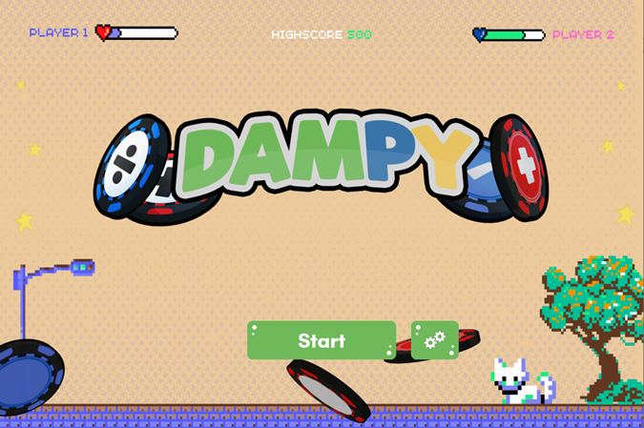  
*Fig. 5: Dampy main title screen*

* + 1. **Buttons**

Upon pressing the Start button, the user will be taken to the Game Scene after a brief transition. If the user presses the Options button instead, they will be taken to the Board Theme Selection Menu.

*Fig. 6: Start and Options button*

* + 1. **Options**

Here in the Options screen is the Board Theme Selection Menu. The user can choose their preferred Damath board to use in-game here, navigating using the Arrow keys. The game features over 10+ custom boards, accommodating users of all personalities.

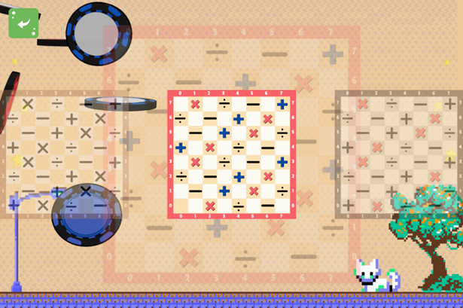   
*Fig. 5: Options button*

* 1. **Game Scene.**

In this scene is where the main Damath game can be played, featuring the different game elements, namely the board, chips, and scoreboard that will aid the users in playing the game. At the top-left corner is the “Pause” button, which pauses the game and takes the user to the Pause Menu upon clicking.

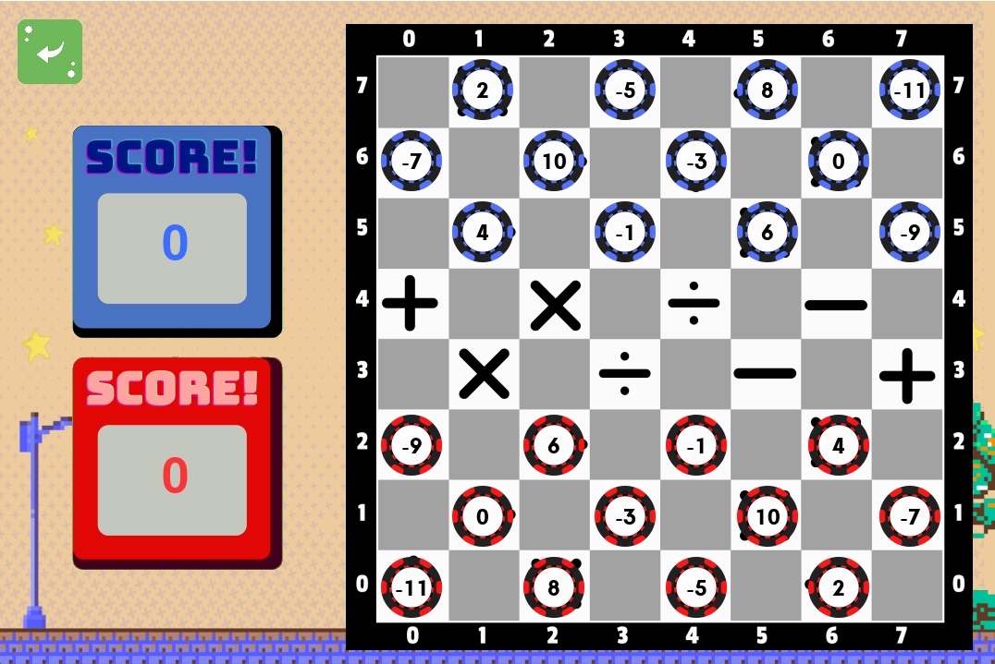  
*Fig. 5: Game scene*

1. **Moves Indicator**

Upon selecting a chip—given that it is that player’s turn, colored dots will appear on the board indicating the possible moves that chip can make.

*Fig. 5: Red dots indicating the red 6 chip’s possible moves*

1. **Scoreboard**

The scoreboard on the left, displays the current players’ accumulated score and is colored accordingly.

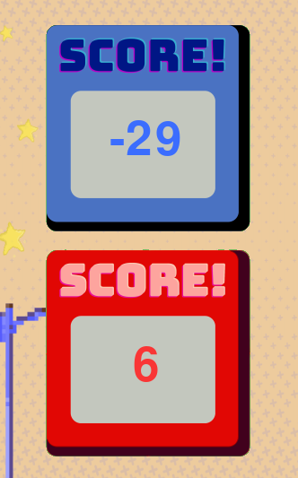  
*Fig. 5: Scoreboard*

* 1. **Pause Menu**

The Pause Menu features four different buttons with different functionalities. Also included here is a spinning chip indicating the color of the player who is currently moving.

*Fig. 5: Pause menu, with the Blue player’s turn*

1. **Pause Menu Buttons**

Pressing the “Resume” button will close the Pause Menu and will take the user back to the Game Scene

Pressing the “Restart” button will restart the game, resetting all the position of the pieces, and player scores.

Pressing the “Options” button will take the user to the Board Theme Selection Menu.

Pressing the “Quit Game” button will take the user back to the Main Title Screen, losing all progress.

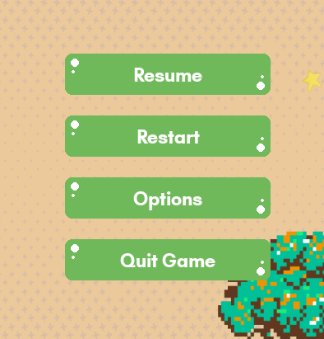  
*Fig. 6: Pause menu buttons*

**PROJECT TEAM**

**PROJECT MANAGER**Buenconsejo, Gian Paolo

Responsibilities:

* + Provide the framework for the project,
  + Coordinate everyone’s activities,
  + Monitor everyone’s contributions and ensuring that tasks are done on time, and
  + Evaluation of the program, ensuring that the production is of satisfactory quality.

**TECHNICAL WRITERS**Masarque, Andy D.  
Famoso, Nina Grace D.

Responsibilities:

* + Create and edit the project technical writings,
  + Accomplishment of the documentation paper, and
  + Preparation the PowerPoint presentation.

**LEAD PROGRAMMER**Velano, John Kenneth M.

Responsibilities:

* + In charge of giving technical directions,
  + Development of the software code, and
  + Assist others to improve the overall codebase.

**TECHNICAL ARCHITECT**Gavino, Bien D.

Responsibilities:

* + In charge of giving technical directions alongside the programmer
  + Conceptualization of the main systems and algorithms
  + Production of the flowchart in which the program will be based on

**SYSTEM ANALYST**

Malabanan, John Russelle B.

Responsibilities:

* + Analyze and design improvements for the program,
  + Discover issues with the program and suggest solving techniques, and
  + Ensure that the program is working properly, free from bugs and errors.

**PROJECT MILESTONES**

* Project Identification: December 9, 2022
* Project Design: December 10, 2022
* Project Development: December 11, 2022
* Project Presentation: December 16, 2022

**ACKNOWLEDGEMENT**

We, as a group, would like to acknowledgment each and every member of our team as they have contributed significantly to the “DAMPY: Damath in Python” project. With a single member gone, this project would not have been possible.

We also like to extend our thanks to John Paul M. Beltran for providing our program with one (2) musical scores. These tracks are used in the program’s Title Screen, and Game Scene, and are named “Entrance” and “unnamed” respectively.

We also want to express our gratitude to Tim, the content creator, who had served as our guide for the development of our program, and for providing a three-part series of making a “Checkers” program in Python. This project would not have been possible without it.

Lastly, we would also like to thank the developers of the various software and applications we used to create our project.

**REFERENCES**

Red, A. (2013). *Effectiveness of Using Damath in Teaching Integers in Grade 7 Students of Fourth District of Quezon*. http://nebula.wsimg.com/1928d6652163924ff1bc8212f9ef1d0f?AccessKeyId=2E307E195F801D332374&disposition=0&alloworigin=1

Doroja, G. (2013). *Mobile DaMath: A Game for Basic Numeracy Exercise. International Journal of Art and Technology.* Academia. https://www.academia.edu/44629148/Mobile_DaMath_a_game_for_basic_numeracy_exercise

Tech With Tim (2020, September 5). *Python/Pygame Checkers Tutorial (Part 1) - Drawing the Board [Video].* YouTube. https://youtu.be/vnd3RfeG3NM

Tech With Tim (2020, September 9). *Python/Pygame Checkers Tutorial (Part 2) - Jumping and King Movement [Video].* YouTube. https://youtu.be/LSYj8GZMjWY

Tech With Tim (2020, September 12). *Python/Pygame Checkers Tutorial (Part 3) - Drawing the Board [Video]*. YouTube. https://youtu.be/_kOXGzkbnps

Anonymous (n.d.). *Pygame Documentation*. Pygame. https://www.pygame.org/docs/

Laoyan, S. (2022). *What is the PRINCE2 project management methodology?* Asana. https://asana.com/resources/prince2-methodology